# InterMedia Mobile App Project Overview

## Charter

InterMedia is a digital directory of users’ collections of music, movies, and books. Users will be able to search for and add items to their collections. They will also be able to locate record stores and bookstores around them. Users will have the option to upload their collections via a CSV file. In future versions, users will be able to sell items from their collections to other users through an online marketplace and communicate with other users on a forum.

## Objectives for InterMedia App

* Deliver an app that has an intuitive interface and works well
* Encourage new members to subscribe through the app
* Deliver an app with an engaging interface and user experience that is targeted to media collectors

## Indicators of Success / Goals

* Increased downloads
* Increased sign ups through the app
* Increased number of 5-star ratings
* Increased usage/daily page views

## Production Overview

* Develop user persona
* Content Analysis / Site Map
* Wireframing / Interface Design / System Flow
* Produce Comps
* Code Production
* Testing
* Deployment
* Promotion
* Ongoing Analysis and Maintenance

## Feature Set

* Account creation
* Database searches
* Adding items to your collection
* Geolocation to search stores near you
* Submit information to the database

**Total Planning and Design Budget: $58,000**

InterMedia Site Map

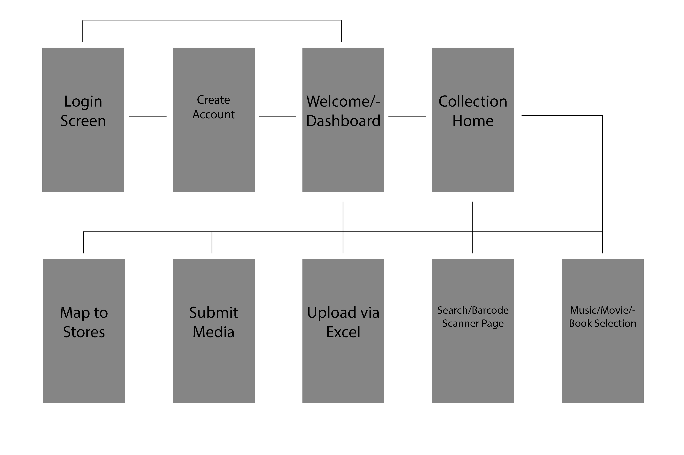

InterMedia Wireframes

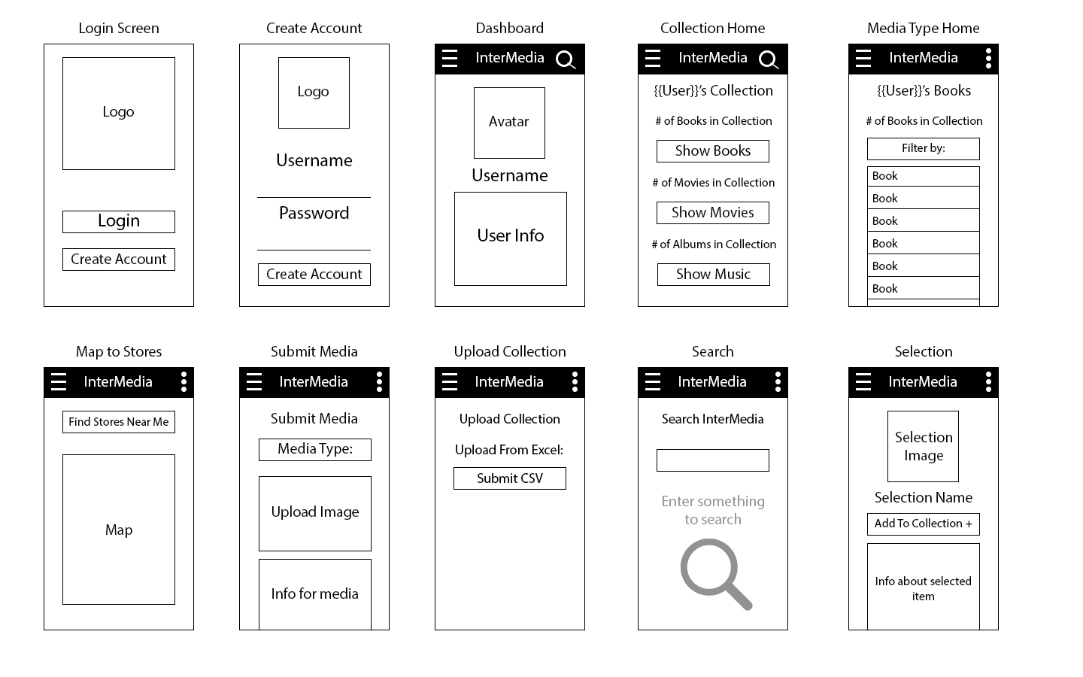

## Projected Timeline

Sept 29, 2017

* Green Light
* Given word via email or phone to start work
* *25% payment due*

Sept 30 – Oct 9

* Develop Persona, Site Map, Wireframes, Comps
* Gather database information

Oct 10

* Meeting via telephone or person
* Present designs and project planning documents
* *75% payment due – Net 15*

Oct 11 – Oct 17

* Revise designs and documents as per Oct 10 meeting
* Develop Interactive Comps

Oct 18

* Present second draft and comps of designs to finalize

Oct 19 – Nov 28

* Create pages from finalized design
* Link databases
* Test app
* Correct any issues that occurred during testing

Nov 29, 2017

* Deliver final design comps and documents

# Persona – Harlan Sullivan

|  |  |  |
| --- | --- | --- |
| **Occupation:**  Owner of Right Round Records | **Age:**  35 years old | **Location:**  Asheville, NC |

#### “Where is the nearest record store?”

He would like:

* The ability to archive all of his physical media into one database
* To be able to locate all of the record stores around him when he travels
* A platform to sell some of his media

## We want him to feel:

* Comfortable with the interface
* Excited about the content
* Satisfied with the performance

|  |  |
| --- | --- |
| Description Harlan is very proud of his collection of different types of media. Owning a record store has given him access to multiple different formats of music, movies, and books.  He is comfortable using a computer and considers himself an intermediate user. He is connected at work and home via wireless modem. He always has his phone connected to the internet and uses the web about 3 hours everyday.  Harlan has previously been recording his collection on an Excel spreadsheet. While this has been adequate for his own record, he would like to be able to share it and connect with other collectors throughout the world. | Motivation Harlan is looking for a way to digitally catalog his current collection. Goals Harlan would like to share his digital catalog with other collectors to connect and possibly sell items with them. Concerns Harlan has used another cataloging app but is not happy with the user interface. He is concerned that InterMedia might not improve on that design. Primary Needs Harlan wants an easy-to-use database with filters and clear searches. He wants to be able to find new record stores and bookstores when he is traveling. |